COAL CITY UNIVERSITY
ENUGU-ABAKILIKI RD, EMENE, ENUGU 400104, ENUGU

DEPARTMENT OF COMPUTER SCIENCE

SIX MONTHS REPORT ON SIWES INDUSTRIAL WORK EXPERIENCE SCHEME (SIWES)

AT
LILY SOLUTIONS LIMITED
19, WOLE SOYINKA AVENUE, 2ND AVENUE, GWARINPA BWARI, ABUJA 900108, FCT

MBAEGBU, CHIMDALU JUSTICE
2022/20931COS

APRIL - SEPTEMBER, 2025
COAL CITY UNIVERSITY
ENUGU-ABAKILIKI RD, EMENE, ENUGU 400104, ENUGU

DEPARTMENT OF COMPUTER SCIENCE

SIX MONTHS REPORT ON SIWES INDUSTRIAL WORK EXPERIENCE SCHEME (SIWES)

AT
LILY SOLUTIONS LIMITED
19, WOLE SOYINKA AVENUE, 2ND AVENUE, GWARINPA BWARI, ABUJA 900108, FCT

MBAEGBU, CHIMDALU JUSTICE
2022/20931COS

SUBMITTED IN PARTIAL FULFILLMENT OF THE REQUIREMENTS FOR THE AWARD OF BACHELOR OF SCIENCE (B.Sc) DEGREE, IN THE FACULTY OF NATURAL AND APPLIED SCIENCES, COAL CITY UNIVERSITY, ENUGU STATE.

DEDICATION

I wholeheartedly dedicate this report, first and foremost, to God Almighty for His divine wisdom, strength, and grace that sustained me throughout my six-month SIWES programme at Lily Solutions Limited. I also dedicate it to my parents and siblings for their unwavering love, encouragement, and support, as well as to all who, in one way or another, contributed to making my SIWES training both enriching and successful.

CERTIFICATION

I hereby certify that MBAEGBU CHIMDALU JUSTICE, a student of the Department of Computer Science, Coal City University, with Matriculation Number 2022/20931COS, has successfully completed the six-month Students’ Industrial Work Experience Scheme (SIWES) at Lily Solutions Limited, Abuja, from April to September 2025, in partial fulfillment of the requirements for the award of the Bachelor of Science (B.Sc.) degree in Computer Science.

___________________________________ _______________
MBAEGBU CHIMDALU JUSTICE DATE

__________________________________ _______________
SUPERVISOR DATE

ACKNOWLEDGMENTS

I wish to express my profound gratitude to God Almighty for the gift of life, wisdom, and knowledge granted to me throughout the duration of this Industrial Training programme.
I am sincerely grateful to Coal City University and the Department of Computer Science for providing me with the opportunity to participate in the Students’ Industrial Work Experience Scheme (SIWES), which has greatly contributed to my academic and professional development.
My heartfelt appreciation goes to my industry supervisor, Mr. Joseph, for his invaluable guidance, mentorship, and continuous support in reviewing my progress and ensuring that my training was both impactful and productive. I also extend my gratitude to my colleagues and friends whose collaboration, encouragement, and contributions made the learning process both engaging and enriching.
Finally, I owe my deepest gratitude to my beloved parents, siblings and relatives for their unwavering support throughout the course of this programme. Their financial assistance, moral encouragement, and constant prayers were instrumental in enabling me to perform to the best of my ability. I sincerely appreciate their sacrifices and steadfast belief in me, and I pray that God Almighty will continue to bless and reward them abundantly.
.

ABSTRACT

This report summarises my six-month Industrial Training under the Students’ Industrial Work Experience Scheme (SIWES) at Lily Solutions Limited, where I gained practical experience in web development, Chrome extension creation, Git/GitHub version control, and teaching web technologies. Key projects included a Lead Tracker Chrome Extension, a responsive personal portfolio website, and various JavaScript mini-projects. I also facilitated beginner web development classes for children, enhancing both technical and communication skills. The training improved my problem-solving, teamwork, and proficiency in HTML, CSS, JavaScript which is the front-end aspect of Web Development, and version control, bridging the gap between classroom theory and real-world application.

TABLE OF CONTENTS

Cover Page 1
Title Page 2
Dedication 3
Certification 4
Acknowledgement 5
Abstract 6
Table of Contents 7

Chapter 1
Introduction
Purpose of Training 8
Brief Story of SIWES 9
Bodies involved in SIWES 9
Nature and Scope of SIWES 10
Aims and Objectives of SIWES 10
Benefits of Industrial Training 11
Roles of Students 12
The Log Book 12
Objectives of the report 12

CHAPTER 1
INTRODUCTION

1.1 PURPOSE OF TRAINING:
The student industrial work experience scheme (SIWES) popularly called Industrial Training (IT) by Nigerian students is a yearly program design by the institution in collaboration with the industries to give students the opportunity to gain practical working experience in their various field of study or area of specialization. It is an effort to bridge the existing gap between classroom theories and practical’s in engineering, management and other professional programs in the Nigerian tertiary institutions.
Training is a key factor in changing expertise of a workforce. The world is passing through one of the worst economic crisis in recent time. Both the developed and developing economics are experiencing serious economic downturns.
Globalization has turned the world into one big village and whatever happens in one economy will have effects in other economics, and the growing concern among our industrialist is that graduates of our institutions of higher learning, lack adequate practical background studies, so as to help in the industries led to the formation of Student Industrial Work Experience Scheme (SIWES) by ITF 1993/1994.
It is through this Industrial Training that the educational systems aims at helping students acquire appropriate skills, abilities and competencies, both mental and physical, as well as equip the individuals to live in society. The focus of the Industrial Training Fund (ITF) is for the industries of our countries to succeed in the face of the current economic meltdown. No society can achieve meaningful progress without encouraging its youth to acquire necessary practical skills. Such skills enable them to harness available resources to meet the needs of the society. It was against this background that SIWES, otherwise referred to as industrial Training (IT), was introduced in Nigerian tertiary institution.

1.2 SIWES: (Student Industrial Work Experience Scheme)

Since the aim of our national policy in education is to build a strong and self- reliant nation, from the government’s decree No.47 of 8th October, 1971 as amended in 1990, which led to the establishment of Industrial Training Fund (ITF) in 1973/1974 and through the formation of this body (ITF), in the year 1993/1994 and through the formation of this body (ITF), in the year 1993/1974 SIWES was formed. In Nigeria, the current form of Cooperative Education is known as the Students Industrial Work Experience Scheme (SIWES).

The Students Industrial Work Experience Scheme (SIWES) is a planned and supervised training intervention based on stated and specific learning and career objectives and geared towards developing the occupational competencies of the participants. The aim is make education more relevance and also to bridge the science-related disciplines in tertiary institutions in Nigeria.

SIWES forms part of the approved minimum academic standards in the institutions, and is a core academic requirement carrying fifteen (15) credit units. This requirement must be met by all students in various disciplines before graduation.

1.3 BODIES INVOLVED IN SIWES:
The main bodies involved in Student Industrial Work Experience Scheme are; The tertiary institutions and the Federal Government through the Industrial Training Fund (ITF).
Other supervising agencies include:
- National University Commission (NUC)
- National Board for Technical Education (NBTE)
- National Council for colleges for Education (NCCE)
- Industry/Employers (NECA, NACCIMA, MAN, Government Establishments)
- Tertiary Institutions (Universities, Polytechnics, Colleges of Education)
- Student Trainees (Engineering, Science, Technology, NCE Technical).

The functions of these agencies above are to:
  - Ensure adequate funding of the scheme
  - Establish SIWES and accredit SIWES unit in the approved institutions
  - Formulate policies and guideline for participating bodies and institutions as well as appointing SIWES coordinators and supporting staff
  - Supervise students at their places of attachment and sign their log book and ITF forms.
  - Vet and process students Log books and forward same to ITF area office
  - Ensure payment of all allowances for the students and supervisors.

1.4 NATURE AND SCOPE OF SIWES:

This is based on the number of weeks or months that student is expected to stay for its attachment. The minimum duration for SIWES should normally be six months, twenty-four weeks (24) weeks for University Engineers and Technologist. The cumulative total duration of attachment over the entire period of the course should preferably be not shorter than 240hrs full time which will take place during term-time or long vocation.
Induction sessions which is conducted by teaching departments to install the concepts of key skills (skills for learning, employment and life), work place safety and professional expectations, legalities and ethics.

1.5 AIMS AND OBJECTIVES OF SIWES:
The specific aims and objectives of SIWES were summarized by the federal government as follows:
    - To provide students with an opportunity to apply their knowledge in real work and actual practice.
    - To make the transition from school to the world of work easier and to enhance students contacts for later job placement.
    - Advanced countries, with over 100 years of sustained industrial development and requisite technical and human infrastructure, have been able to adequately implement industrial training for their students.
    - They also include providing a structural attachment program with emphasis applications, management and hands-on experience for students to apply knowledge acquired.
    - It also aids students to acquire practical skill in other to strengthen their work value.

1.6 BENEFITS OF INDUSTRIAL TRAINING:
- To gain a profound appreciation of the pivotal role played by various professions within their respective domains, as the architects of change and wealth, and as indispensable contributors to the growth of the economy and national development.
- Students cultivate and refine personal attributes, including critical thinking, creativity, initiative, resourcefulness, leadership, effective time management, presentation skills, and strong interpersonal capabilities, encompassing both oral and written communication.
- Students demonstrate the capacity to apply their technical knowledge and methodologies to real-world scenarios effectively.
- The objective is to thoroughly prepare students for successful employment, facilitating a seamless transition from the academic environment to the professional world upon graduation.
- Students gain firsthand exposure to the operational dynamics and organizational structures of businesses and companies. Additionally, they observe the interactions between their respective professions and other professional groups, fostering a comprehensive understanding of collaborative dynamics.
- Students have the valuable opportunity to gain firsthand professional experience during their attachment.

1.7 ROLES OF STUDENTS

- Participation in SIWES Orientation: Attend the SIWES orientation program to prepare for your attachment experience.
- Adherence to Establishment Regulations: Comply diligently with all rules and regulations set forth by the hosting establishment.
- Accommodation Arrangement: Make suitable arrangements for your living accommodation throughout the attachment period.
- Logbook Documentation: Maintain a detailed logbook to record all training activities and assignments completed during your attachment.
- Completion of Required Forms: Ensure the completion of essential documentation, including the SPEI from ITF and FORM 8. These forms must be endorsed by your employer before submission to the ITF.

1.8 THE LOG BOOK

During the attachment period, students were provided with logbooks by the institution, which served as a comprehensive record of daily activities. These logbooks were meticulously reviewed, checked, and endorsed by both industry-based and institution-based supervisors, as well as the ITF during regular supervision sessions.

1.9 OBJECTIVES OF THIS REPORT

The fundamental objective of this report includes the following:
- To fully describe the nature of training undergone specifically in the area of my field of study.
- To enumerate the experience I required during the SIWES program.
- To make observations and recommendations based on my experience during the training.

CHAPTER 2
DESCRIPTION OF THE ESTABLISHMENT OF THE ATTACHMENT
2. 1 BACKGROUND OF THE COMPANY

FIGURE 2.1 - LILY SOLUTIONS LIMITED, ABUJA, FCT.
Lily Solutions Limited is a dynamic and innovative technology solutions provider established in 2018, committed to delivering high-quality digital services tailored to meet the needs of businesses, institutions, and individuals. The company specializes in web development, software engineering, IT consultancy, and digital transformation projects. They equally specialize in delivering comprehensive business support services designed to elevate your brand and accelerate growth.
With a team of highly skilled professionals, Lily Solutions Limited focuses on delivering cutting-edge solutions that integrate functionality, user experience, and modern design principles. The company serves clients in sectors such as education, finance, e-commerce, and public services, helping them leverage technology for operational efficiency and competitive advantage.

2.2 CORE AREAS OF EXPERTISE:
Lily Solutions Limited has great skills in the following field:
      - Web Design & Development: Creating responsive, user-friendly websites and web applications using HTML, CSS, JavaScript, and modern frameworks.
      - Software Solutions: Developing custom software tools tailored to specific business requirements.
      - IT Consultancy: Offering advisory services to organisations on IT infrastructure, digital transformation strategies, and technology adoption.
- Training & Capacity Building: Organising workshops and training programs on web development, programming, and emerging technologies like AI animation.
- Videography and Photography: Offers a good quality in terms of video coverage, photo shot and video editing.

2.3 MISSION AND VISION STATEMENTS OF LILY SOLUTIONS LIMITED.
Mission Statement:
To empower businesses and individuals through innovative, efficient, and scalable technology solutions that drive growth and transformation.
Vision Statement:
To be a leading IT solutions provider in Nigeria and across Africa, recognised for quality, creativity, and customer satisfaction.

2.4 ORGANOGRAM OF LILY SOLUTIONS LIMITED
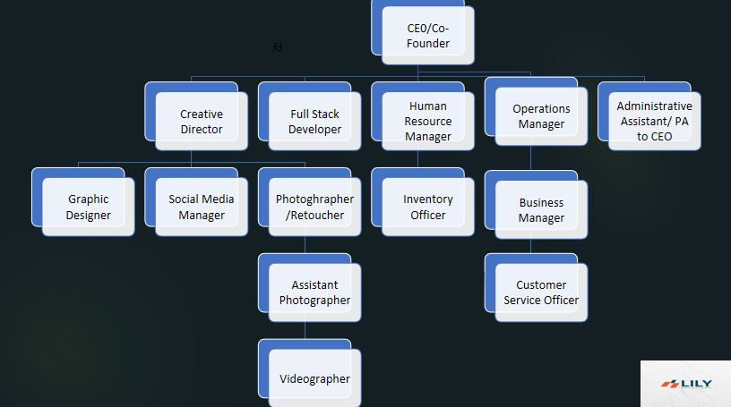
Figure 2.2 - Organizational Chart of Lily Solutions Limited.

CHAPTER 3
INDUSTRIAL EXPERIENCE

3.1 WEB DEVELOPMENT DEPARTMENT (FRONT-END)
This department was where my Industrial Training took place where I was grounded and expose to the website world especially the creation of websites taking me step by step with practical all through the process.

3.2 DEFINITION OF TERMS
The following are terms that were made use of, in this department:
      - WEBSITE: A website is a set of related webpages containing content such as texts, images, videos, audios, etc. A website is hosted on at least one web server, accessible via a network such as the internet or a private LAN through an internet address known as a URL (Universal Resource Locator). A publicly accessible websites collectively constitutes the World Wide Web (WWW).
      - WEBPAGE: A webpage is a document, typically written in plain text interspersed with formatting instructions of hypertext nark up language (HTML, XHTML). A webpage may incorporate elements from other websites with suitable anchors. Webpages are accessed and transported with the hypertext transfer protocol (HTTP), which may occasionally employ encryption (HTTP secure, HTTPS) to provide security and privacy for the use of the webpage content. The user’s application often a web browser renders the page content according to its HTML mark-up instructions into a display terminal.
      - HTTP: This stands for Hyper Text Transfer Protocol which is the set of rules for transferring files (text, graphic, images, sound, video, and other multimedia files) on the World Wide Web.
      - URL: This stands for Uniform Resource Locator and as the name suggests, it provides a way to locate a resource on the web, the hypertext system that operates over the internet.

3.3 HTML AND ITS PROPERTIES
HTML stands for Hypertext Mark-up Language, and it is the most widely used language to write Web Pages.
- Hypertext refers to the way in which Web pages (HTML documents) are linked together. Thus, the link available on a webpage is called Hypertext.
- As its name suggests, HTML is a Markup Language which means you use HTML to simply "mark-up" a text document with tags that tell a Web browser how to structure it to display.
Originally, HTML was developed with the intent of defining the structure of documents like headings, paragraphs, lists, and so forth to facilitate the sharing of scientific information between researchers.
Now, HTML is being widely used to format web pages with the help of different tags available in HTML language.

3.3.1 HTML TAGS:
As told earlier, HTML is a markup language and makes use of various tags to format the content. These tags are enclosed within angle braces <Tag Name>. Except few tags, most of the tags have their corresponding closing tags. For example, <html>has its closing tag</html>and <body>tag has its closing tag </body>tag etc.
The following are the names of tags and their description:
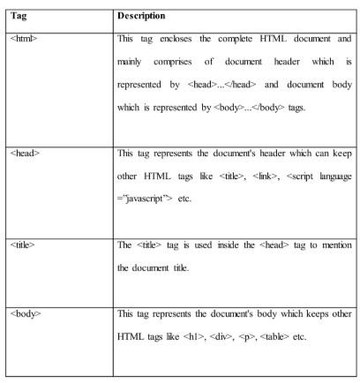

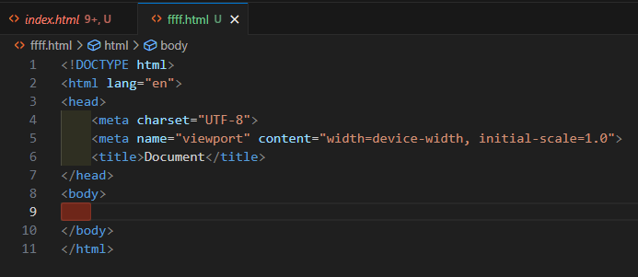
FIGURE 3.3.1 - A SIMPLE HTML PAGE.
3.4 CSS AND ITS PROPERTIES
CSS stands for Cascading Style Sheet used for formatting html document. It is a style sheet language used for describing the presentation of a document written in a mark-up language.
Note: CSS code is not written the same way as HTML code is. This makes sense because CSS is not HTML, but rather a way of manipulating existing HTML.

3.4.1 REASONS FOR CSS
The following are reasons why CSS is better:
- It saves time.
- It eradicates the idea of using repeating codes.
- It provides efficiency in design and updates: with CSS, we are able to create rules, and apply those rules to many elements within the website.
- It can lead to faster page downloads: since rules are only downloaded once by the browser, then are the cached and used for each page load, the use of CSS can lead to lighter page loads, and improved performance. This contributes to lighter server loads and lower requirements, which overall saves money for our clients.
- It creates external file (server side) for managing html content.

3.4.2 METHOD USED BY CSS IN FORMATTING HTML DOCUMENT
- Inline Style: It is used to apply a unique style to a single HTML element. An inline CSS uses the style attribute of an HTML element.
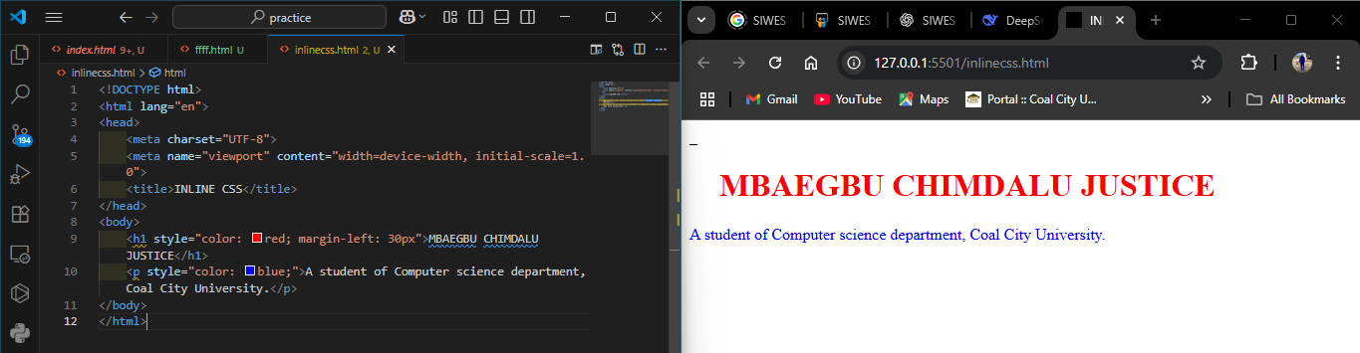FIGURE 3.4.2 - CODE AND DESIGN VIEW OF AN INLINE CSS.
- Embedded / Internal Style: It is used if one single page has a unique style. Internal styles are defined within the <style> element, inside the <head> section of an HTML page.

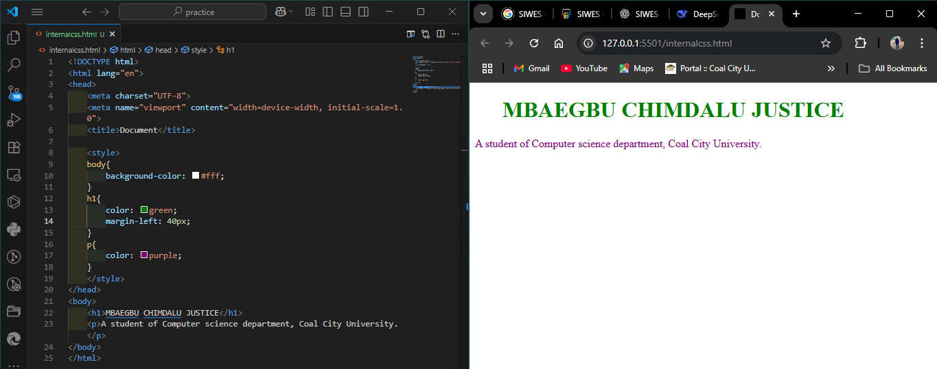
FIGURE 3.4.2 - CODE AND DESIGN VIEW OF AN INTERNAL/EMBEDDED CSS

- External Style: With an external style sheet, you can change the look of an entire website by changing just one file. Each page must include a reference to the external style sheet file inside the <link> element. The <link> element goes inside the <head> section. Also when using external CSS it is preferable to keep the CSS separate from your HTML. Placing CSS in a separate file allows the web designer to completely differentiate between content (HTML) and design (CSS). External CSS is a file that contains only CSS code and is saved with a “.css” file extension. This CSS is then referenced in your HTML using the <link> instead of <style> as earlier stated.
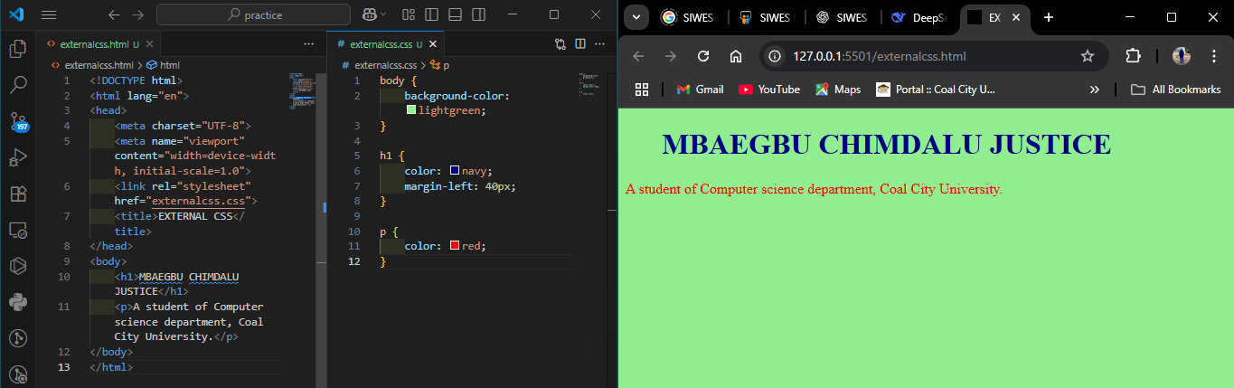FIGURE 3.4.2 – CODE AND DESIGN VIEW OF AN EXTERNAL CSS.
3.4.3 CSS SELECTORS AND HOW THEY CAN BE USED
CSS selectors are used to find or select HTML elements based on their element name, id or class
      - Element Selector: The element selector selects elements based on the element name.
      - Id Selector: The id selector uses the id attribute of an HTML element to select a specific element. The id of an element should be unique within a page, so the id selector is used to select one unique element. e.g. id=”hello” css #hello { color;red;}
      - Class Selector: The class selector selects elements with specific class attribute. To select elements with a specific class, write a period (.) character followed by the name of the class. e.g. .center {text-align:center;}

3.4.4 CSS RULES OVERRIDING
- Any inline style sheet takes the highest priority, so it will override any rule defined in <style>……</style> tags.
- Any rule defined in <style>………</style> tags will override the rules defined in any external style sheet file.

3.4.5 CSS COMMENTS
To simply put comment inside a style sheet you use /*………..*/, you can use it to comment multi-line blocks in similar way as you do in c and c++ programming language. It’s shortcut on a windows operating system is Ctrl + / .

3.4.6 BACKGROUND AND FONT OF VARIOUS HTML ELEMENTS
You can set the following background properties of an element.
- The background-color: Is a property used to set the color background of an element.
- The background-image property: is used to set the background image of an element.
- The background repeat: Is used to control the repetition of an image in the background.
- The background position: Is used to control the position of an image in the background.
- The background attachment: Is used to control the scrolling of an image in the background.
- The background property: Is used as a short hand to specify a number of other background properties.

FONTS WHICH ARE:
- The Font-family property: This is used to change the face of a font
- The Font-style property: This is used to make a font italic or oblique.
- The Font-weight property: This is used to increase or decrease how bold or light a font appears.
- The Font-size property: This is used to increase or decrease the size of a font.

3.4.7 TEXT DECORATION
This demonstrate how to decorate a text in css, the values are none, underline, over line, line through and blink.

3.4.8 PROPERTIES OF HYPERLINK USING CSS
- The link signifies unvisited hyperlinks
- The link visited signifies visited hyperlinks
- The link hovered signifies an element that currently has the user’s mouse pointer hovering over it.
- The link active signifies an element on which the user is currently clicking.

3.4.9 WEBSITE DESIGN USING HTML AND CSS
MY HTML CODES:
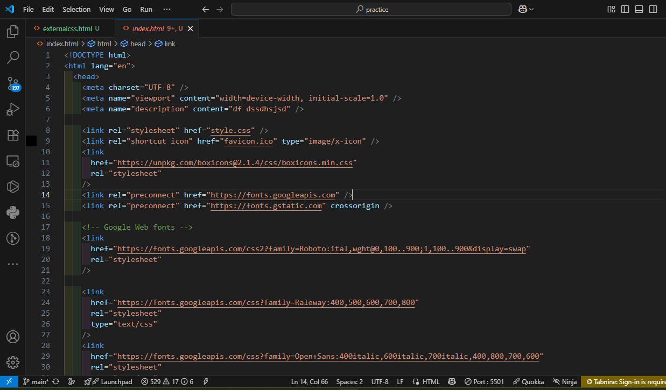

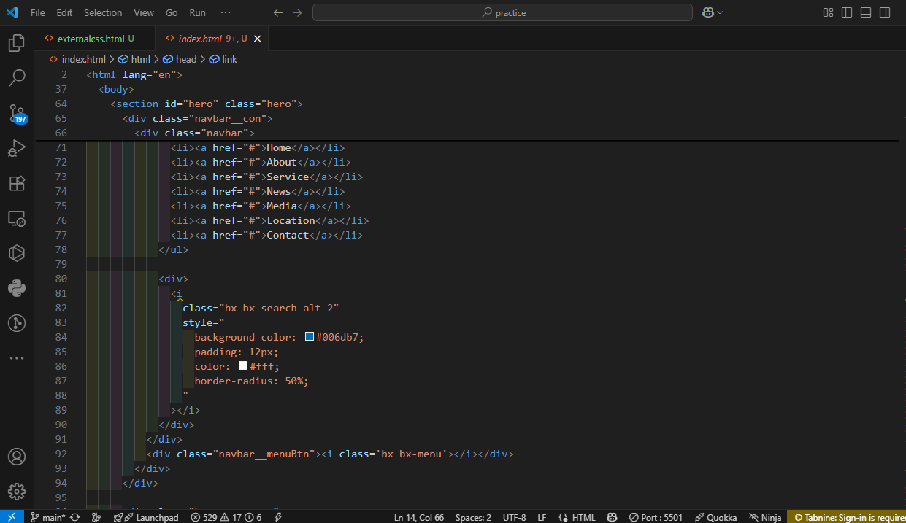

FIGURE 3.4.9 - SOME OF MY HTML CODES.

MY CSS CODES:
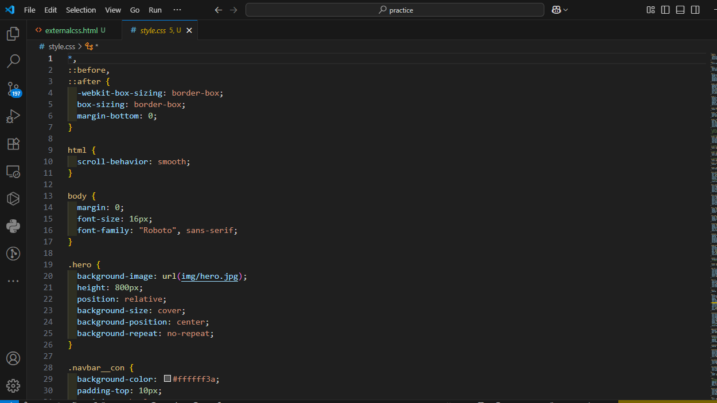
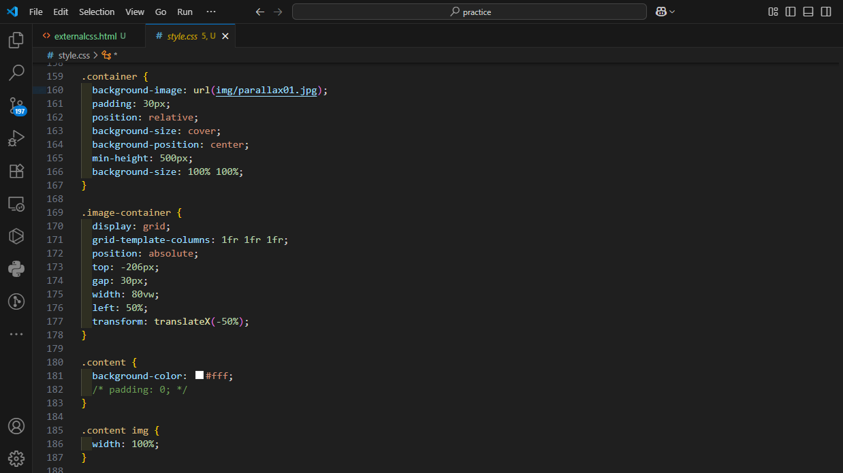
FIGURE 3.4.9 - SOME OF MY CSS CODES

THE WEBSITES CREATED WITH THE HTML AND CSS:







THE TRUCKING AND LOGISTICS WEBSITE I BUILT.
3.5 JAVASCRIPT AND ITS PROPERTIES
JavaScript is a dynamic computer programming language. It is lightweight and most commonly used as a part of web pages, whose implementations allows client side script to interact with the user and make dynamic pages. It is an interpreted programming language with object oriented capabilities. It was developed by Brenan Eich 1995-1996; it is an implementation of ECMA Script (European Computer Manufacturers Association). It was also known as livescript later change to javascript. It is use for client side web form validation. Javascript cannot run with been embedded in the HTML.

3.5.1 FUNCTIONS OF JAVASCRIPT
- It is most commonly used as a client side scripting language, which implies that javascript is written into an HTML page and when a user request an HTML page with javascript in it, the script is sent to the browser.
- It used for form validation.

3.5.2 BROWSER DETECTION
This refers to a feature of a web browser to execute a javascript code without any error irrespective of its version.
3.5.3 ADVANTAGES OF JAVASCRIPT
- Less server interaction: You can validate user input before sending the page off to the server. This saves server traffic, which means fewer loads on your server.
- Immediate feedback to the visitors: They don’t have to wait for a page to reload to see if they forgotten to enter something.
- Increased interactivity: You can create interfaces that react when the user hovers over them with a mouse or activates them via the keyboard.
- Richer interfaces: You can use javascript to include such items as drag and drop component and sliders to give a rich interface to your site visitors.

3.5.4 JAVASCRIPT DEVELOPMENT TOOLS
One of the major strengths of javascript is that it does not require expensive development tools. One can begin with a simple text editor such as notepad or notepad++. Since it is an interpreted language inside the context of a web browser, you don’t even need to buy a compiler.
However to make life simpler, various vendors have come up with very nice javascript editing tools, they are macromedia Dreamweaver.

3.5.5 JAVASCRIPT SYNTAX
JavaScript can be implemented using javascript statements that are placed within the <script>…………..</script> HTML tags in a web page. You can place the <script> tags, containing your javascript, anywhere within your web page, but it is normally recommended that we should keep it within the <head> tags
The script tag takes two important attributes:
- Language: This attribute specifies what scripting language I am using.
- Type: This attribute is what is now recommended to indicate the scripting language in use and its value should be set to “text/javascript”.

3.5.6 COMMENTS IN JAVASCRIPT
JavaScript supports both c-style and c++ style comments.
Thus:
- Any text between a // and the end of a line is treated as a comment and is ignored by JavaScript.
- Any text between the characters /* and */ is treated as a comment. This may span multiple lines.
- JavaScript also recognizes the HTML comment opening sequence <!--. JavaScript treats this as a single-line comment, just as it dos the //comment.
- The HTML comment closing sequence --!> is not recognized by JavaScript so it should be written as //-->

3.5.7 MY JAVASCRIPT PROGRAM TO OUTPUT MY NAME CODE VIEW DESIGN VIEW
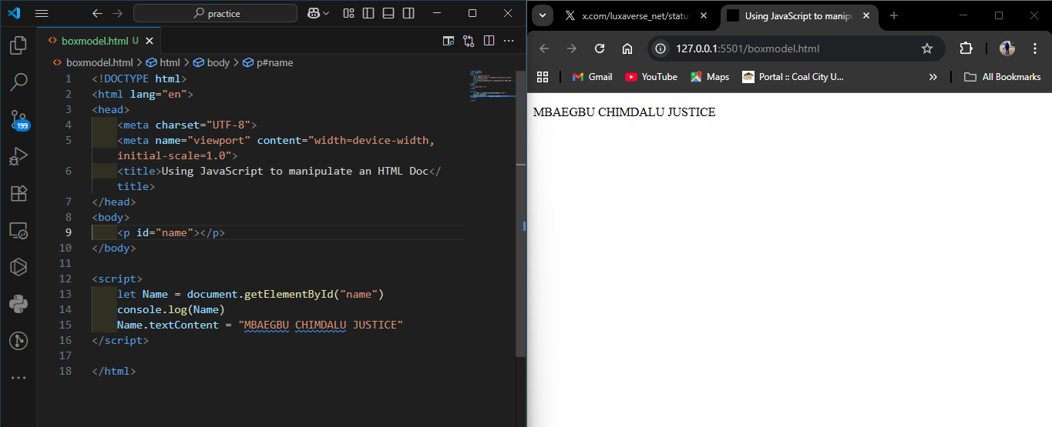
FIGURE 3.4.7 - CODE AND DESIGN VIEW OF A SIMPLE JS FILE.

3.5.8 HOW TO ENABLE JAVASCRIPT IN BROWSER
I was taught that all the modern browsers come with built-in support for JavaScript. Frequently, we may need to enable or disable this support manually. The following procedure will help us to enable and disable JavaScript in our browsers.

3.5.8.1 JAVASCRIPT IN GOOGLE CHROME
Here are the steps to turn on JavaScript in Chrome:
- Click the Chrome menu at the top right hand corner of your browser.
- Select Settings.
- Click Show advanced settings at the end of the page. Under the Privacy section, click the Content settings button.
- In the “JavaScript” section “Allow any site to run to JavaScript.
3.5.9 DATA TYPES IN JAVASCRIPT
One of the most fundamental characteristics of a programming language is the set of data types it support. These are the type of values that can be represented and manipulated in a programming language. They include:
- Numbers: This represents numeric values e.g. 100.
- Strings: This represents sequence of character e.g. Hello.
- Boolean: This represents Boolean value either true or false
- Null: This represents nothing i.e. it can be empty.
- Undefined: This represents undefined values.
- Object: This represent values return by functions.

3.5.10 JAVASCRIPT VARIABLES
In JavaScript, a variable is a named memory location used to store values that can be referenced and manipulated within a program. Variables allow developers to store data such as numbers, strings, objects, and functions for later use.
To create a variable, JavaScript provides three keywords: var, let, and const. Declaring a variable introduces it to the JavaScript engine, while initializing it assigns an initial value.
EXAMPLES OF DECLARATION AND INITIALIZATION.
var name; // Declaration
name = "John"; // Initialization
let age = 25; // Declaration + Initialization
const country = "Nigeria"; // Constant value

Differences Between var, let, and const
- var
-Introduced in older versions of JavaScript (ES5 and earlier).
- Function-scoped: Variables declared with var are accessible throughout the function in which they are declared.
- Allows redeclaration within the same scope.
- Can be reassigned.
- Can cause unexpected behavior due to hoisting.
Example:
var x = 10;
var x = 20; // Redeclaration allowed
x = 30; // Reassignment allowed

- let
- Introduced in ES6 (2015) to fix scoping issues with var.
- Block-scoped: Accessible only within the block {} where it is declared.
- Cannot be redeclared in the same scope, but can be reassigned.
Example:
let y = 10;
// let y = 20; // Error: redeclaration not allowed
y = 30; // Reassignment allowed

- const
- Also introduced in ES6.
- Block-scoped, like let.
- Cannot be redeclared or reassigned after initialization.
- Must be initialized at the time of declaration.
- However, for objects and arrays, properties or elements can still be modified.
Example:
const z = 10;
// z = 20; // Error: reassignment not allowed
const person = { name: 'John' };
person.name = 'David'; // Allowed: modifying property of an object

Summary Table
Feature | var | let | const
Scope | Function | Block | Block
Redeclaration | Allowed | Not allowed | Not allowed
Reassignment | Allowed | Allowed | Not allowed
Hoisting Behavior | Yes (undefined) | Yes (TDZ*) | Yes (TDZ*)
*TDZ: Temporal Dead Zone – variable exists but cannot be accessed before declaration.

3.5.10.1 VARIABLE NAMES
While naming the variables in JavaScript, the following rules should be kept in mind.
You should not use any of the JavaScript reserved keywords as a variable name. For example, break or Boolean
JavaScript variable names should not start with a numeral (0-9). They must begin with a letter or an underscore character. For example, 931justice is an invalid name but _931justice, justice is a valid one.
JavaScript variable names are case-sensitive. For example, Justice and justice are two different variables.
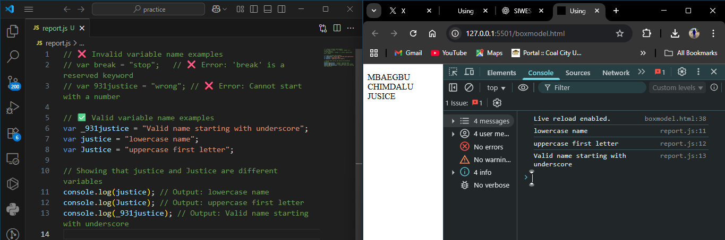
FIGURE 3.5.10.1 - CODE AND DESIGN VIEW OF A CORRECT VARIABLE NAME.

3.5.10.2 OPERATORS
In JavaScript, operators are special symbols used to perform operations on values and variables. For example, in the expression 4 + 5 = 9, the numbers 4 and 5 are called operands, while the plus sign (+) is called the operator.
JavaScript supports several categories of operators:
      - Arithmetic Operators
These are used to perform mathematical calculations. Assuming A = 10 and B = 20:

- Addition (+) → Adds two numbers. Example: A + B = 30
- Subtraction (-) → Subtracts one number from another. Example: A – B = -10
- Multiplication (*) → Multiplies two numbers. Example: A * B = 200
- Division (/) → Divides one number by another. Example: B / A = 2
- Modulus (%) → Returns the remainder of a division. Example: B % A = 0
- Increment (++) → Increases a variable by 1. Example: A++ = 11
- Decrement (--) → Decreases a variable by 1. Example: A-- = 9

      - Comparison Operators
Used to compare two values and return true or false. Assuming A = 10 and B = 20:
- Equal (==) → Checks if values are equal. Example: (A == B) is false
- Not Equal (!=) → Checks if values are not equal. Example: (A != B) is true
- Greater Than (>) → Checks if the left value is greater. Example: (A > B) is false
- Less Than (<) → Checks if the left value is smaller. Example: (A < B) is true
- Greater Than or Equal (>=) → Checks if left value is greater or equal. Example: (A >= B) is false
- Less Than or Equal (<=) → Checks if left value is smaller or equal. Example: (A <= B) is true

- Logical Operators
Used to combine or invert conditions:
- Logical AND (&&) → Returns true if both conditions are true. Example: (A < B && B > 15) is true
- Logical OR (||) → Returns true if at least one condition is true. Example: (A > B || B > 15) is true
- Logical NOT (!) → Reverses the result. Example: !(A < B) is false

- Assignment Operators
Used to assign values to variables:
- = → Assigns a value. Example: C = 5
- += → Adds and assigns. Example: C += 3 (C becomes 8)
- -= → Subtracts and assigns. Example: C -= 2 (C becomes 6)
- *= → Multiplies and assigns. Example: C *= 2 (C becomes 12)
- /= → Divides and assigns. Example: C /= 4 (C becomes 3)

- Conditional Operators
A shorthand for writing if–else conditions:
- Syntax: condition ? valueIfTrue : valueIfFalse
- Example: (A > B) ? "A is greater" : "B is greater" → returns "B is greater"

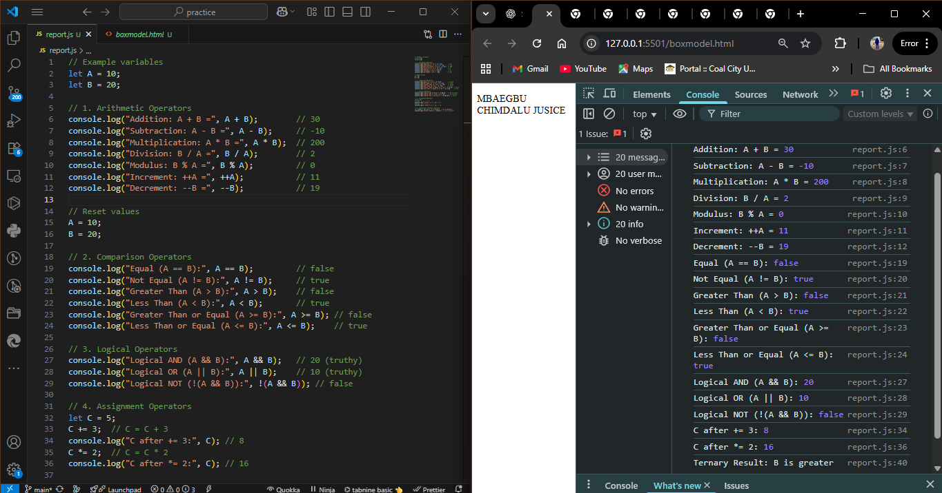
FIGURE 3.5.10.2 - JS CODES AND OUTPUT OF ALL THE JS OPERATORS DISCUSSED ABOVE
3.5.11 SELECTION STATEMENTS
When writing a program, there may be a situation when we need to adopt one out of a given set of paths. In such cases, conditional statement were used which allows our program to make correct decisions and perform right actions. The following selection statements are supported by JavaScript are:
      - IF STATEMENT: This is the fundamental control statement that allows JavaScript to make decisions and execute statements conditionally.
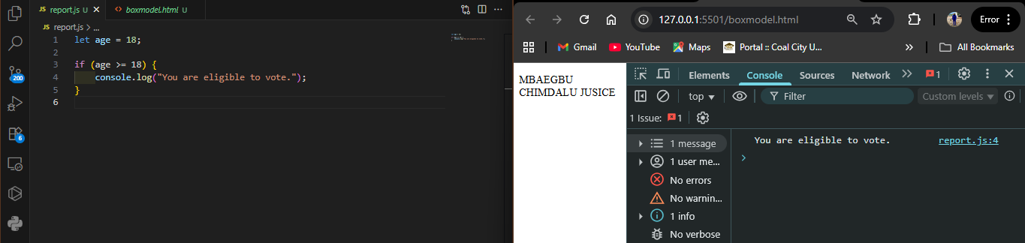
FIGURE 3.5.11 - CODE AND OUTPUT OF AN IF STATEMENT

      - IF-ELSE STATEMENT: This is the next form of the selection statement that allows JavaScript to execute statements in a more controlled way.
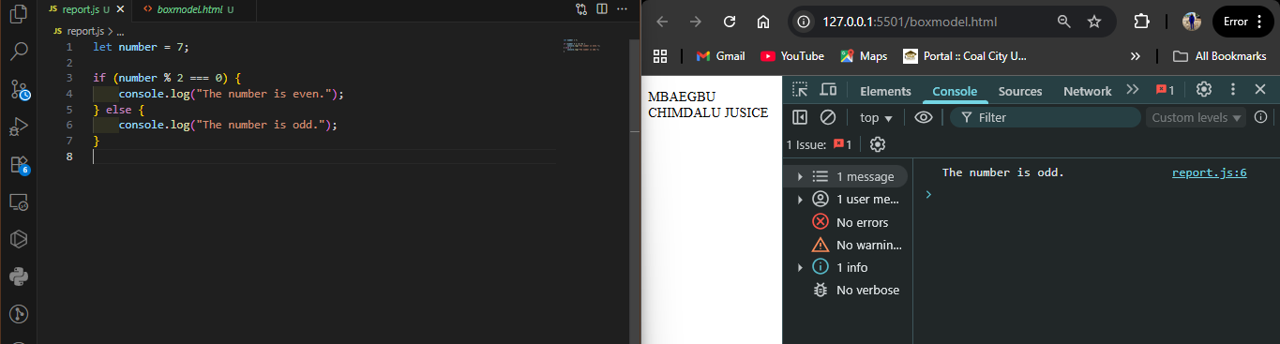
FIGURE 3.5.11 - CODE AND OUTPUT OF AN IF-ELSE STATEMENT

      - IF-ELSE-IF STATEMENT: This is an advanced form of if else that allows JavaScript to make a correct decision out of several conditions.
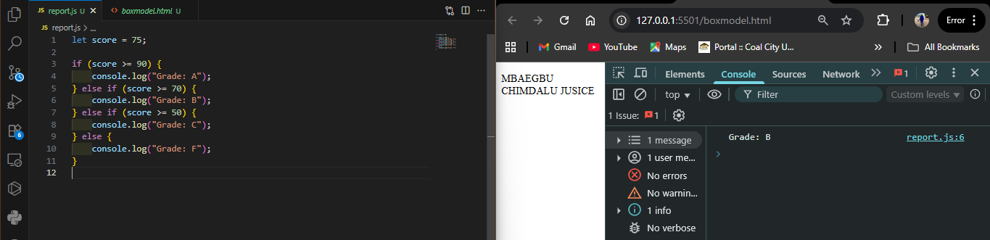
FIGURE 3.5.11 - CODE AND OUTPUT OF AN IF-ELSE-IF STATEMENT

      - SWITCH CASE: Switch case is used to handle situation more efficiently than repeated if-else-if statements.
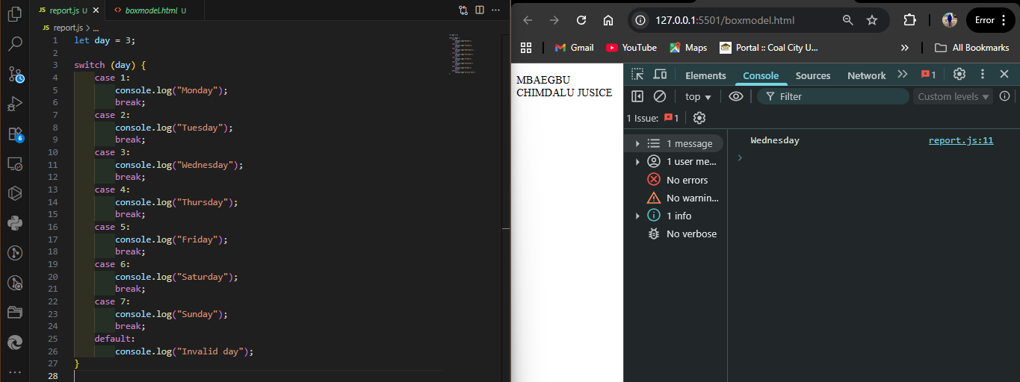
FIGURE 3.5.11 - CODE AND OUTPUT OF A SWITCH CASE STATEMENT
Explanation of the Switch Case Code above:
- The program checks the value of day.
- If day equals 3, it prints “Wednesday.”
- break ensures the program exits after executing the correct case.
- The default block runs if none of the cases match.

    - LOOP STATEMENTS
While writing a program, you may encounter a situation where you need to perform an action over and over again. In such situations, you would need to write loop statements to reduce the number of lines. JavaScript supports all the necessary loops to ease down the pressure of programming.
            - WHILE LOOP: The purpose of a while loop is to execute a statement or code block repeatedly as long as an expression is true. Once the expression becomes false, the loop terminates.
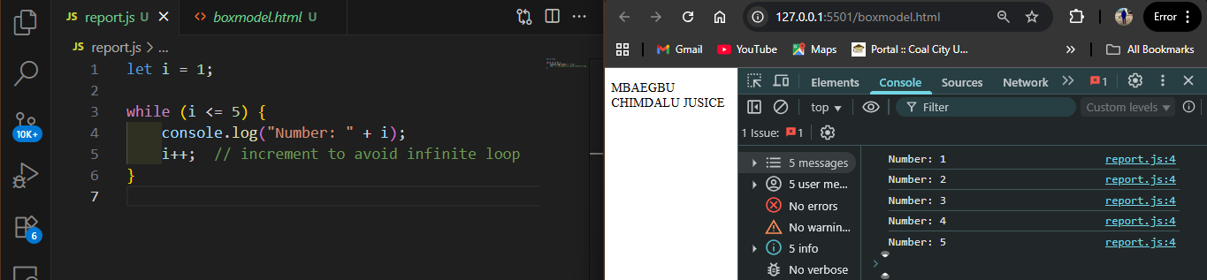
FIGURE 3.5.12 - CODE AND OUTPUT FOR A WHILE LOOP
- This prints numbers 1 to 5.
            - DO WHILE LOOP: This is similar to the while loop except that the condition checks what happens at the end of the loop. This means that the loop will always be executed at least once, even if the condition if false.
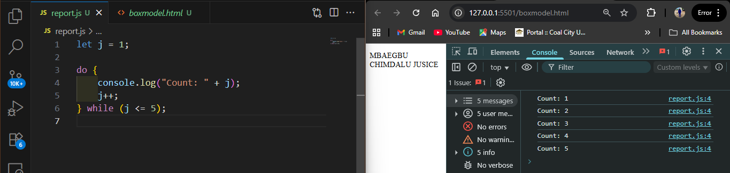
FIGURE 3.5.12 - CODE AND OUTPUT FOR A DO WHILE LOOP
- This also prints numbers 1 to 5, but the loop runs at least once before checking the condition.
            - FOR LOOP: This is the most compact form of looping. It includes the following three (3) important parts:
            - Loop Initialization where we initialize our counter to a starting value. The initialization statement is executed before the loop begins.
            - Test statement which will test if a given condition is true or not. If the condition is true, then the code given inside the loop will be executed, otherwise the control will come out of the loop.
            - Iteration statement where you can increase or decrease your counter.
Note: All this three (3) parts are inserted in a single line separated by semicolons.
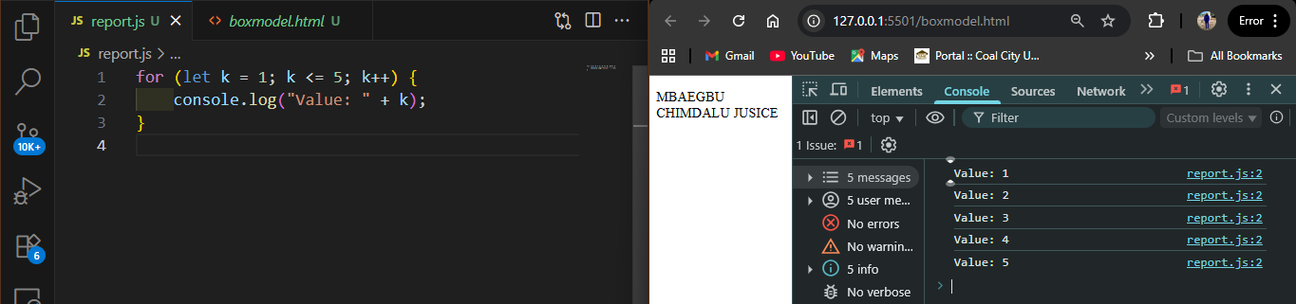
FIGURE 3.5.12 - CODE AND OUTPUT FOR A FOR LOOP

    - FUNCTIONS
A function is a group of reusable code which can be called anywhere in your program. This eliminates the need of writing the same code again and again. It helps programmers in writing modular codes. It allows a programmer to divide a big program into a number of small and manageable functions.
Before we use a function, we need to define it. The most common way to define a function in JavaScript is by using the function keyword, followed by a unique function name, a list of parameters (this might be empty), and a statement block surrounded by curly braces. Also to invoke a function somewhere later in the script, you would simply need to write the name of that function.

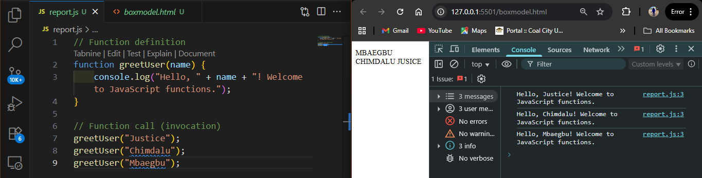
FIGURE 3.5.13 - CODE AND OUTPUT FOR FUNCTIONS.

CHAPTER 4
ACTIVITIES DURING THE SIWES PROGRAM
4.1 INTRODUCTION
The Industrial Training programme at Lily Solutions Limited, Abuja offered me the opportunity to apply classroom knowledge to real-world situations. As a Computer Science student, my focus was on Web Development and Application Design, where I was exposed to industry standards, collaborative environments, and real project cycles.
During the course of my training, I worked on several projects that challenged me to think critically, problem-solve, and strengthen my technical foundation. These projects include:
      - Trucking Website
      - Passenger Counter Application
      - Blackjack Game
      - Chrome Extension (Lead Tracker)
      - Portfolio Website
      - BMI Calculator using Javascript
      - Normal Mathematics Calculator
      - Digital Clock using HTML, CSS and JS
      - Developed a mini-project, a-to-do list app
      - Pricing Table
      - Student grade calculator
      - Sign-up form with validation project
Each of these projects broadened my understanding of HTML, CSS, JavaScript, and modern web practices. Below is a comprehensive discussion of each project.

4.2 TRUCKING WEBSITE
The Trucking Website was one of my earliest projects and served as an introduction to building multi-page websites that simulate business operations. The goal was to design a platform for a logistics company that showcases its services and provides customers with an easy way to reach out. I built various trucking websites that still adopted the same concept of HTML and CSS. Find them in the figures below
Objectives:
            - To apply foundational HTML and CSS concepts in a real-world business setting.
            - To build a simple but functional company website.
Tasks and Implementation:
      - Designed a Home Page with navigation menus, company branding, and a welcoming hero section.
      - Added Service Pages to display the different categories of trucks and their specifications.
      - Designed a Contact Form to simulate customer service inquiries.
      - Applied CSS styling for responsiveness and a professional look.

Skills Gained:
            - Strengthened my understanding of semantic HTML tags and their roles in structuring web pages.
            - Improved my use of CSS selectors, margins, paddings, and layouts.
            - Learned to design websites that are visually appealing and user-friendly.


Figure 4.2 : Landing Homepage of the Trucking Website.


Figure 4.2: Service page of the Trucking Website.


Figure 4.2: Service page of the Trucking Website.


Figure 4.2: Services page of the Trucking Website.


Figure 4.2: Industry Sector page of the Trucking Website.


Figure 4.2: Testimonial page of the Trucking Website.


Figure 4.2: Location page of the Trucking Website.


Figure 4.2: Newsletter page of the Trucking Website.

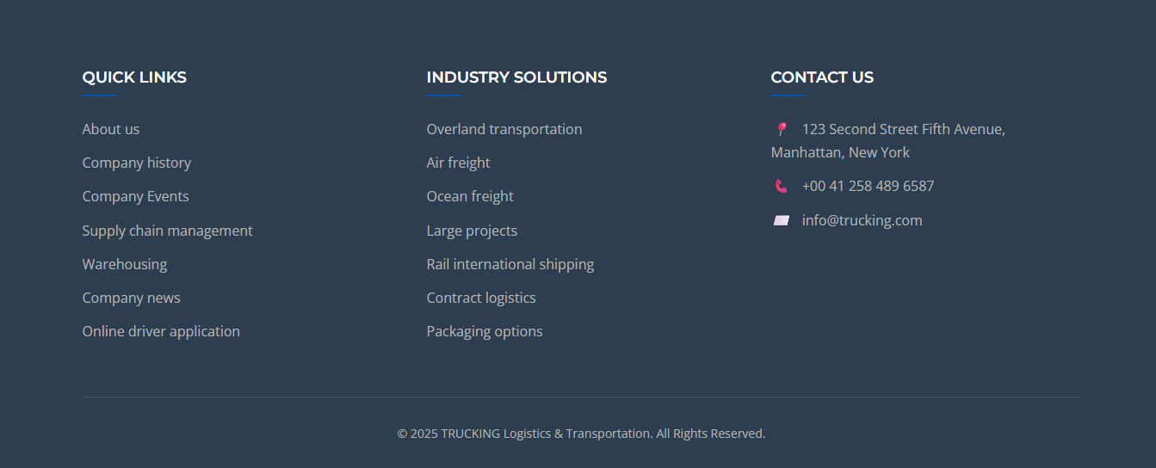
Figure 4.2: Footer of the Trucking Website

Here’s the second Trucking website I built:


Figure 4.2: Homepage of the Trucking Website


Figure 4.2: Services page of the Trucking Website


Figure 4.2: Services page of the Trucking Website


Figure 4.2: Services page of the Trucking Website


Figure 4.2: Industry Sector page of the Trucking Website


Figure 4.2: Company News, Testimonial and Locations of the Trucking Website


Figure 4.2: Footer of the Trucking Website

4.3 PASSENGER COUNTER APPLICATION
This was my first JavaScript-driven project. The Passenger Counter App simulated recording the number of people at a bus station or venue. It was small in scope but powerful in teaching me how JavaScript interacts with HTML and CSS.

Objectives:
            - To understand the practical use of JavaScript variables, functions, and event handling.
            - To practice DOM manipulation.

Tasks and Implementation:
  - Designed a simple user interface with a counter display and buttons.
  - Implemented a counting function to increment passenger numbers when the button is clicked.
  - Added a save function to record entries dynamically.
  - Integrated a reset feature to clear the values and start again.

Skills Gained:
    - Hands-on practice with variables, event listeners, and functions.
    - Clearer understanding of how to manipulate HTML elements dynamically.
    - Learned how to maintain application state within the browser.

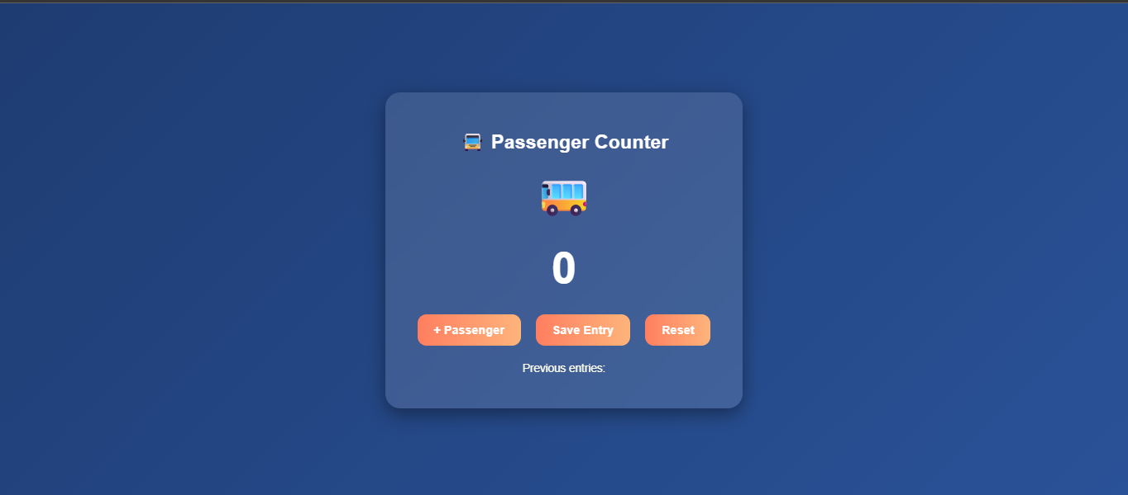
Figure 4.2: Laptop View of Counter App Interface (screenshot placeholder)


Figure 4.2: Mobile View of Counter App Interface (screenshot placeholder)
4.3 BLACKJACK GAME
The Blackjack Game was an exciting project that combined logic, arrays, loops, and conditionals. It was designed to mimic the real-world card game where the player tries to achieve a sum of 21 without going over.

Objectives:
      - To learn complex problem-solving with JavaScript.
      - To gain experience with arrays, random number generation, and decision-making statements.

Tasks and Implementation:
        - Created a card deck simulation using arrays and random number generation.
        - Implemented the game logic: summing card values, checking win/loss conditions.
        - Rendered cards dynamically to the screen.
        - Added feedback messages like “You’re still in the game” or “You’ve got Blackjack!”

Skills Gained:
          - Deeper mastery of loops, conditionals, and arrays in JavaScript.
          - Improved ability to handle game states and dynamic rendering.
          - Strengthened debugging skills while fixing logic errors.


Figure 4.3: Laptop view of Blackjack Game Interface (screenshot placeholder)

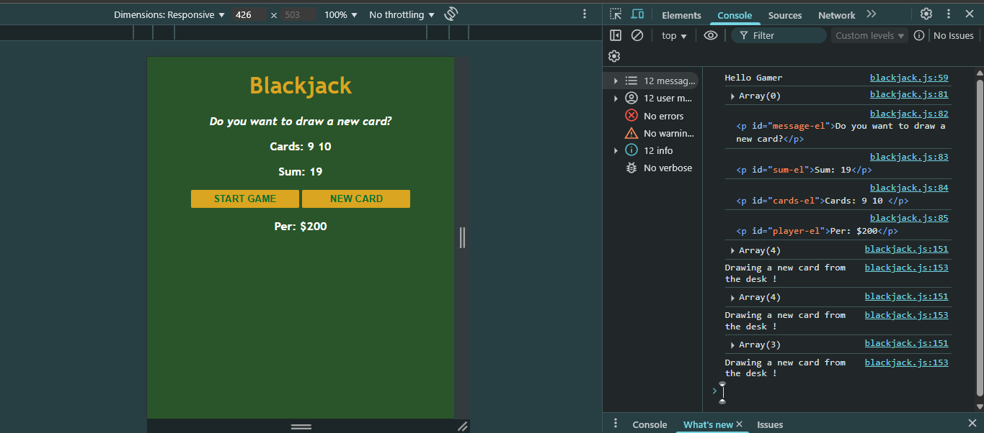
Figure 4.3: Mobile view of Blackjack Game Interface (screenshot placeholder)

4.4 CHROME EXTENSION (LEAD TRACKER)
One of the most advanced projects I worked on was the development of a Chrome Extension for saving leads (URLs). This project gave me real-world insight into how browser extensions work and how they can improve productivity.

Objectives:
            - To build a browser-based productivity tool using HTML, CSS, JavaScript, and Chrome APIs.
            - To learn about local storage for data persistence.

Tasks and Implementation:
              - Designed the user interface with input fields and buttons.
              - Implemented JavaScript functions to store and retrieve data from localStorage.
              - Added functionality to save the current tab URL using the Chrome API.
              - Styled the extension popup for better user experience.
              - Refactored the code for modularity, including a render() function for displaying saved leads.
              - Implemented a double-click delete feature to clear all saved data from storage.

Skills Gained:
                - Advanced understanding of localStorage and Chrome APIs.
                - Knowledge of event-driven programming with addEventListener().
                - Insight into extension deployment and testing.

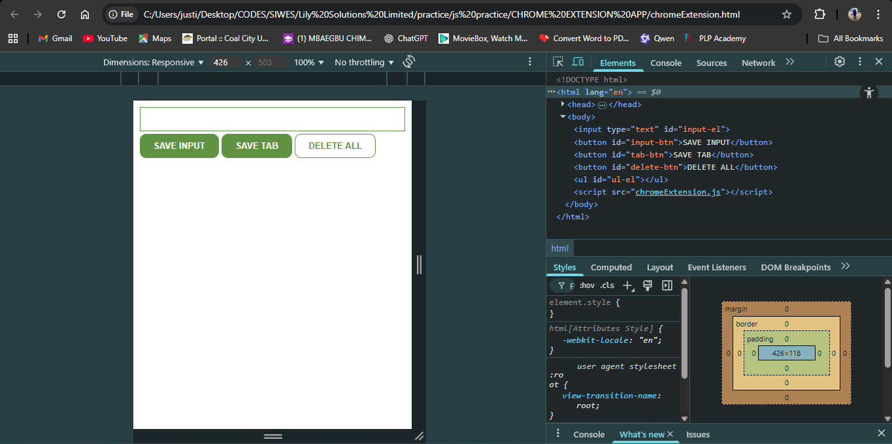
Figure 4.4: Chrome Extension Popup Interface (screenshot placeholder)

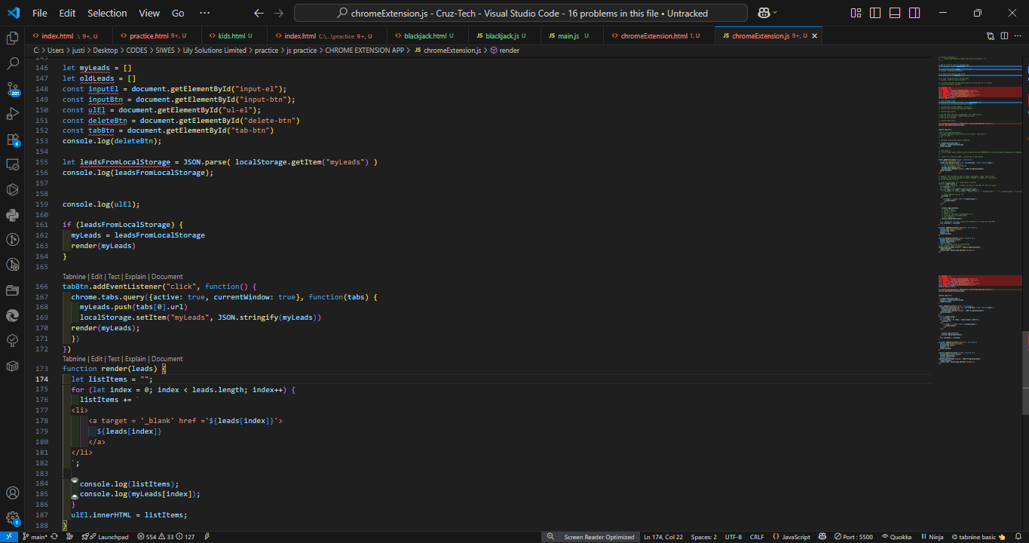
Figure 4.4: Chrome Extension Code Overview (screenshot placeholder)

4.5 PORTFOLIO WEBSITE
The Portfolio Website was one of the most impactful projects because it combined technical skills with personal branding. It was designed to present my profile, skills, and completed projects in a professional and visually appealing way.

Objectives:
      - To create an online presence showcasing my work.
      - To practice advanced CSS styling techniques and layout design.

Tasks and Implementation:
- Built a homepage with an introduction and navigation.
- Designed sections for projects, about me, and contact details.
- Added a downloadable CV link.
- Used CSS grid and flexbox to create a responsive layout adaptable to multiple devices.

Skills Gained:
- Improved my front-end design and layout skills.
- Learned to build responsive websites suitable for professional use.
- Understood the importance of personal branding in tech careers.


Figure 4.5: Portfolio Website Homepage (screenshot placeholder)


Figure 4.5: About me Website page(Skills) (screenshot placeholder)

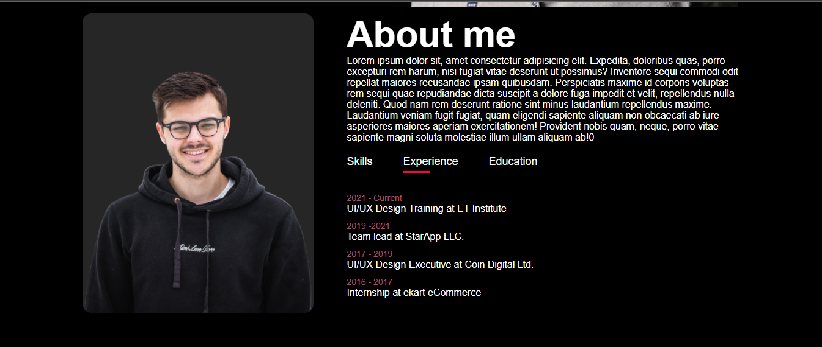
Figure 4.5: About me Website page (Experience)


Figure 4.5: About me Website page(Education)

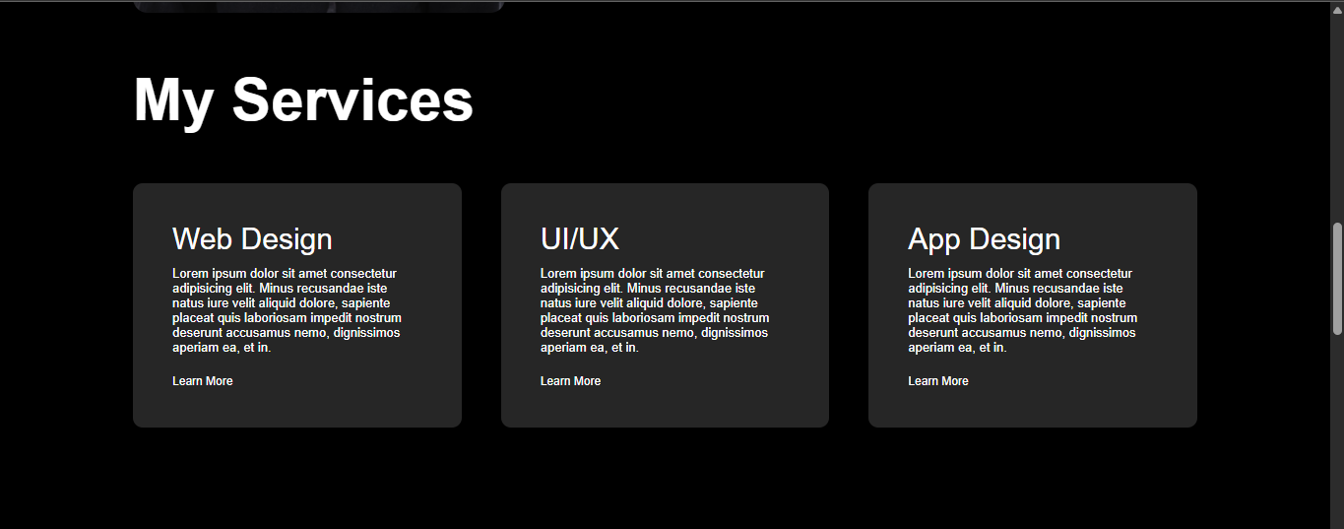
Figure 4.5: Portfolio Website Services page (screenshot placeholder)


Figure 4.5: Portfolio Website Works page (screenshot placeholder)

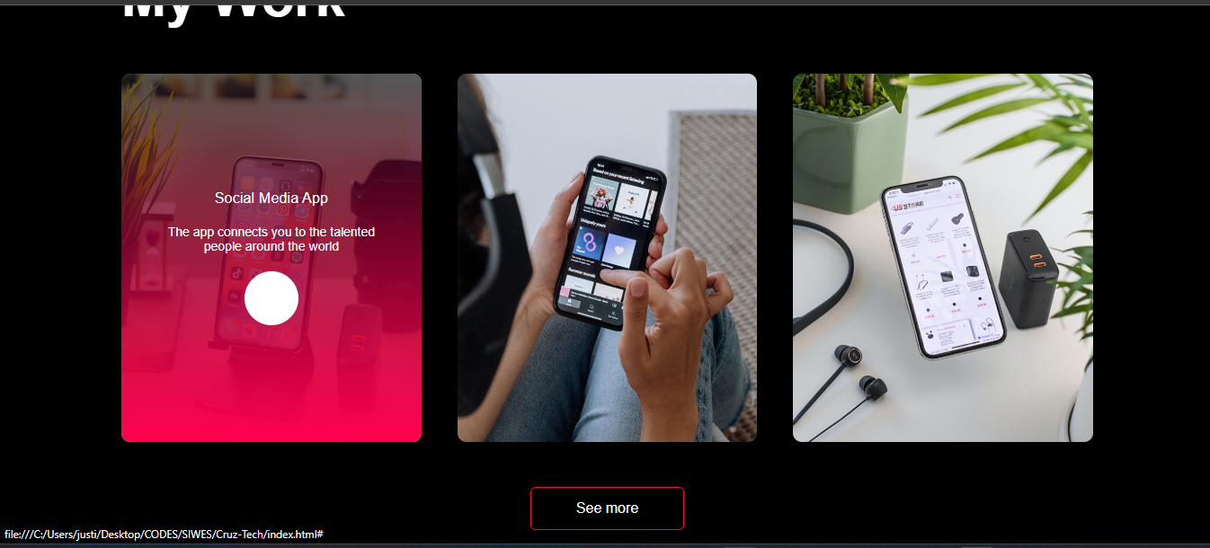
Figure 4.5: Portfolio Website Works page when hovered on (screenshot placeholder)


Figure 4.5: Portfolio Website Works page when hovered on


Figure 4.5: Portfolio Website Works page when hovered on

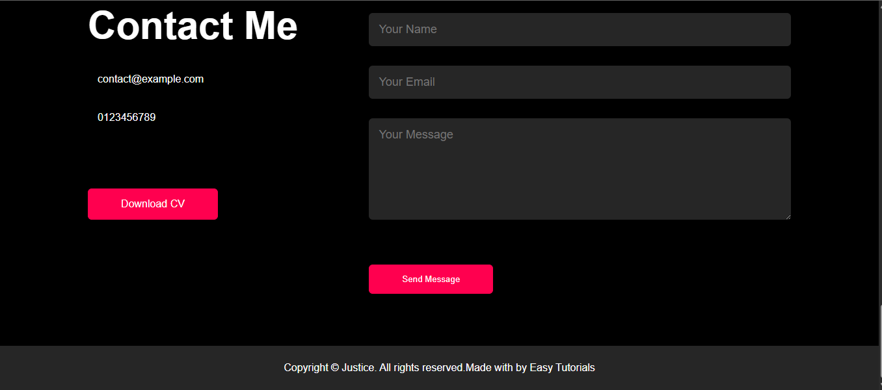
Figure 4.5: Portfolio Website Contact page (screenshot placeholder)

4.6 BMI Calculator using JavaScript
The BMI Calculator project was designed to help users determine their Body Mass Index by inputting their weight and height. This project focused on combining HTML for structure, CSS for styling, and JavaScript for functionality to make it interactive and user-friendly.
Objectives:
- To apply JavaScript in handling user input and performing calculations.
- To build a practical health-related application with clear output.
Tasks and Implementation:
- Created input fields for weight and height entry.
- Added a "Calculate" button that triggers the BMI formula in JavaScript.
- Displayed results dynamically with a health status message (e.g., underweight, normal, overweight).
- Styled the calculator with CSS to make it attractive and responsive.
Skills Gained:
- Strengthened knowledge of JavaScript functions and event handling.
- Learned dynamic DOM manipulation for displaying results.
- Improved user-interface design for simple health apps.

Figure 4.6: Laptop View of the BMI CALCULATOR
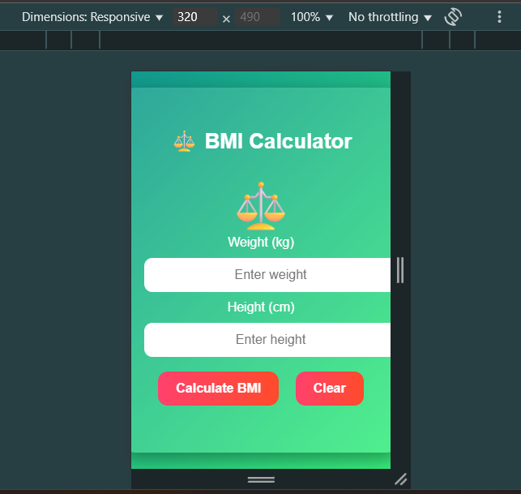
Figure 4.6: Mobile View of the BMI CALCULATOR

4.7 Normal Mathematics Calculator
The Normal Mathematics Calculator simulated a simple Casio-style calculator for performing basic arithmetic operations such as addition, subtraction, multiplication, and division.
Objectives:
- To apply JavaScript for mathematical operations.
- To create an interactive tool that mimics real-life calculators.
Tasks and Implementation:
- Designed a calculator interface with buttons for numbers and operators.
- Used JavaScript to process input values and display results.
- Handled multiple operations, including clearing and resetting values.
- Styled the calculator to make it colorful and interactive.
Skills Gained:
- Enhanced knowledge of JavaScript operators and logic flow.
- Learned to structure code for better functionality.
- Improved UI/UX design skills with CSS.
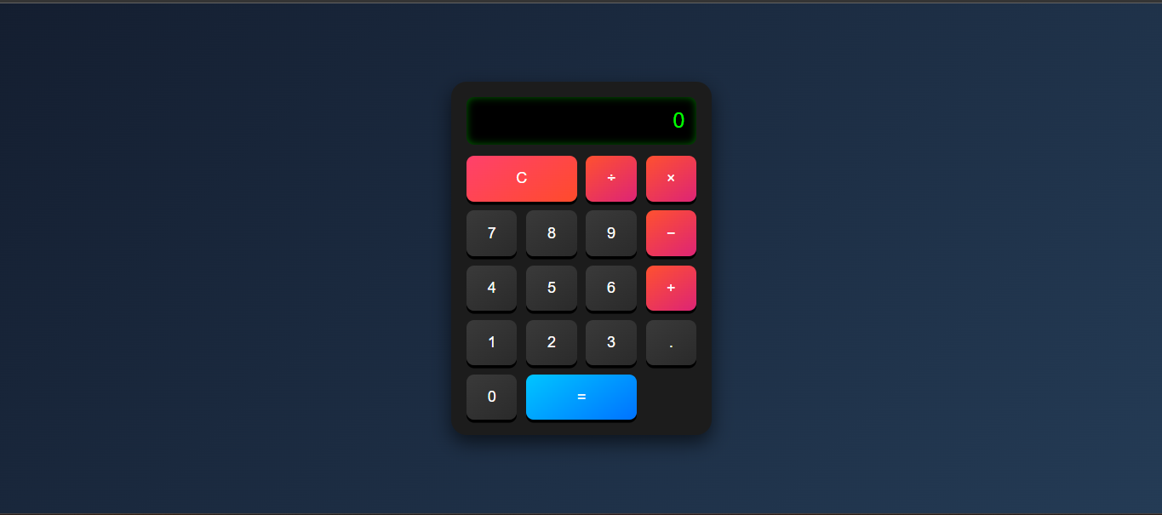
Figure 4.7: Laptop View of the NORMAL CALCULATOR

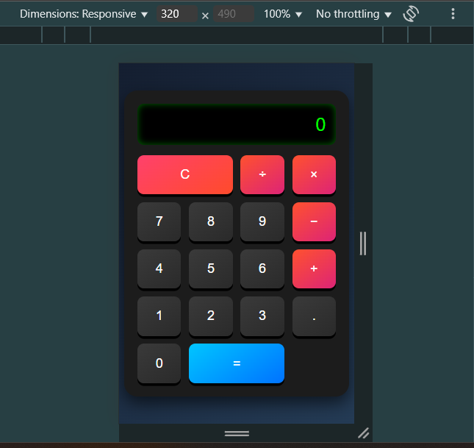
Figure 4.7: Mobile View of the Normal CALCULATOR

4.8 Digital Clock using HTML, CSS, and JS
The Digital Clock project displayed real-time hours, minutes, and seconds using JavaScript. It updated dynamically to simulate a working digital clock.
Objectives:
- To apply JavaScript timing functions in real-world projects.
- To design a real-time updating interface.
Tasks and Implementation:
- Used JavaScript’s setInterval() function to update time every second.
- Displayed time in a large, styled format with AM/PM indication.
- Applied CSS to design a glowing, attractive clock interface.
Skills Gained:
- Gained knowledge of JavaScript Date and Time objects.
- Improved ability to work with intervals and real-time updates.
- Learned to style and position elements effectively in a user interface.

Figure 4.8: Laptop View of the Digital Clock as at that particular time.

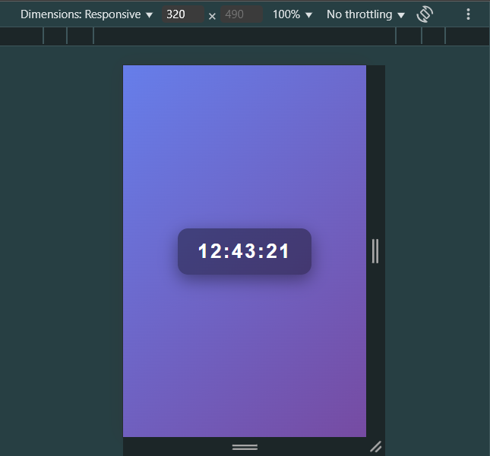
Figure 4.8: Mobile View of the Digital Clock as at that particular time.

4.9 Mini Project: To-Do List App
The To-Do List app was developed as a mini productivity tool to help users add, manage, and remove daily tasks.
Objectives:
- To practice JavaScript array and DOM manipulation.
- To build a practical project with real-life usefulness.
Tasks and Implementation:
- Designed input fields for task entry.
- Added functionality to create, display, and delete tasks.
- Styled the list with alternating colors for clarity.
- Implemented interactivity for better user experience.
Skills Gained:
- Enhanced knowledge of arrays and event handling in JavaScript.
- Learned how to manage data dynamically in a browser.
- Improved understanding of building interactive productivity tools.
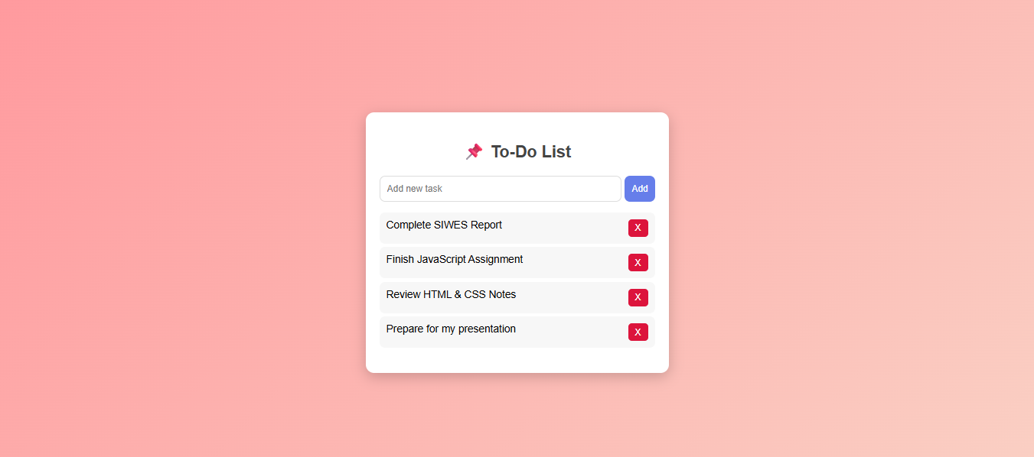
Figure 4.9: Laptop View of the to do list app.

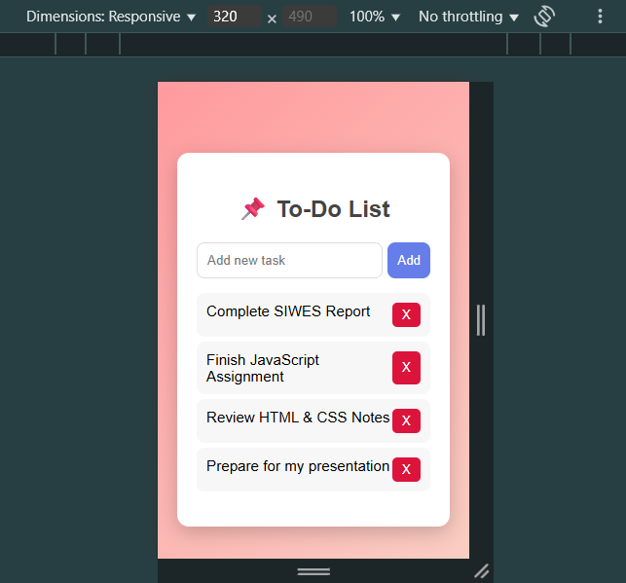
Figure 4.9: Mobile View of the to do list app.

4.10 Pricing Table
The Pricing Table project simulated a company pricing page where services are displayed in tiers (Basic, Standard, Premium).
Objectives:
- To practice CSS layouts and grids.
- To create a responsive pricing structure for businesses.
Tasks and Implementation:
- Designed multiple pricing cards with headings, features, and prices.
- Used CSS flexbox/grid for layout arrangement.
- Styled buttons and hover effects for interactivity.
Skills Gained:
- Gained experience with responsive web layouts.
- Learned to design business-style components.
- Improved skills in structuring and presenting data attractively.

Figure 4.10: Laptop View of the pricing table.

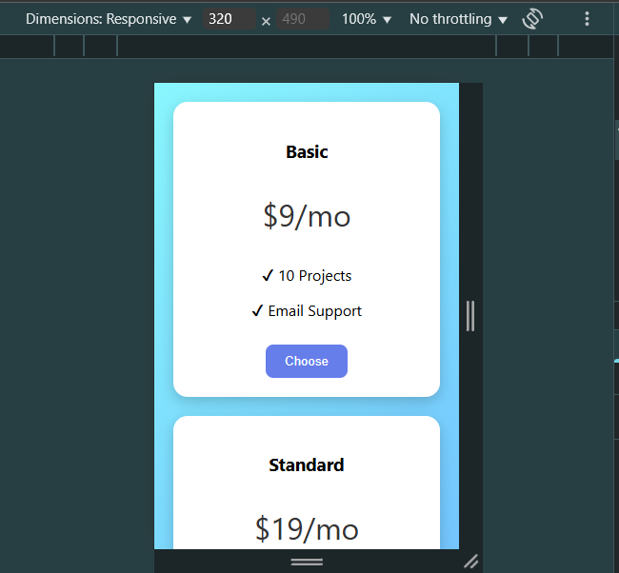
Figure 4.10: Mobile View of the pricing table(Scrollable) .

4.11 Student Grade Calculator
The Student Grade Calculator was developed to compute students’ average scores and grade levels based on inputs.
Objectives:
- To apply JavaScript conditional statements in academic contexts.
- To automate grading processes through simple applications.
Tasks and Implementation:
- Created input fields for entering subject scores.
- Added logic to calculate averages and assign grades (A, B, C, etc.).
- Displayed results dynamically with student feedback.
- Styled the calculator for readability and interaction.
Skills Gained:
- Improved JavaScript conditional and arithmetic operations.
- Learned how to process multiple inputs simultaneously.
- Gained experience in educational application design.
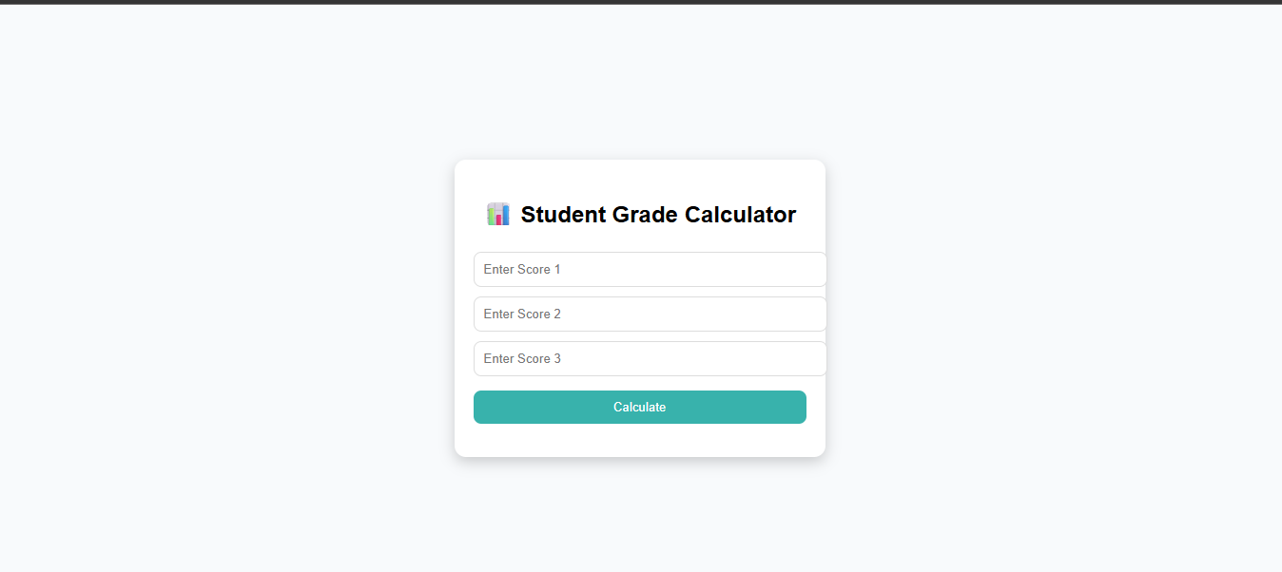
Figure 4.11: Laptop View of the student grade Calculator.

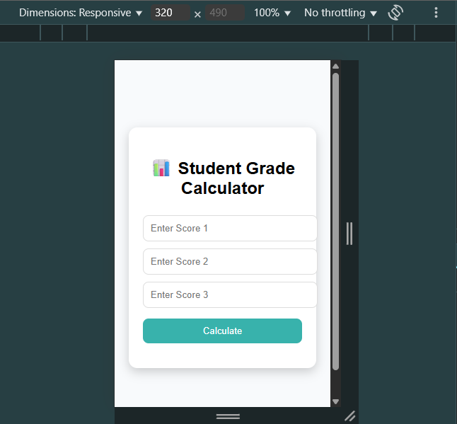
Figure 4.11: Mobile View of the student grade Calculator.

4.12 Sign-Up Form with Validation Project
The Sign-Up Form project simulated a user registration system with client-side validation to ensure correct input.
Objectives:
- To understand form validation techniques using JavaScript.
- To create a secure and user-friendly input system.
Tasks and Implementation:
- Built a form with fields like Name, Email, Password, and Confirm Password.
- Applied JavaScript validation for empty fields, email format, and password match.
- Displayed error/success messages dynamically.
- Styled the form with CSS to make it professional and attractive.
Skills Gained:
- Learned real-world form validation using JavaScript.
- Improved error handling and user feedback methods.
- Enhanced skills in creating secure and accessible web forms.
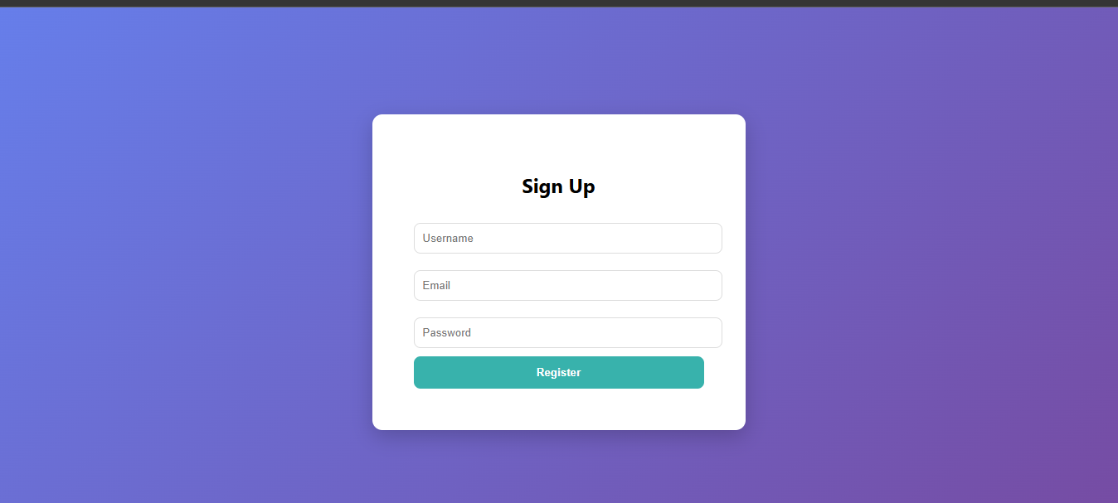
Figure 4.12: Laptop View of the sign up page.

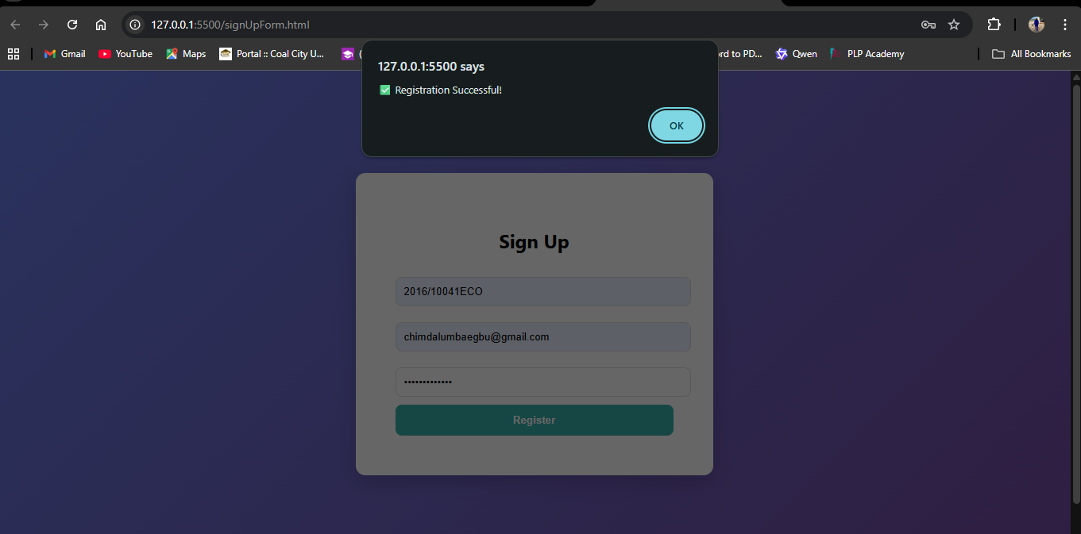
Figure 4.12: Laptop View of the sign up page when registration is successful.

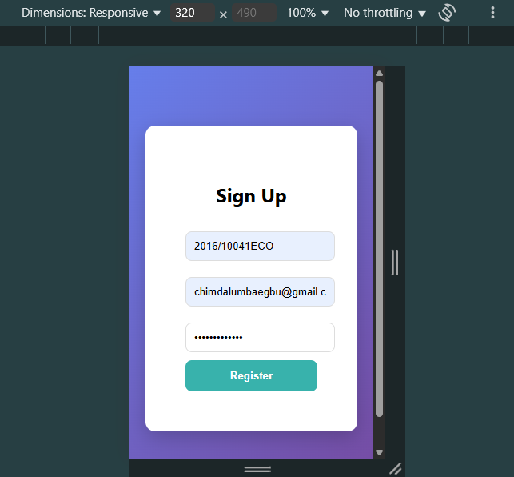
Figure 4.12: Mobile View of the sign up page.

4.13 Summary of Activities
Across these projects, I moved from basic to advanced concepts in web development:
- Starting with simple structures (Passenger Counter, Trucking Website).
- Progressing to logical games (Blackjack).
- Exploring interactive tools and real-world utilities (BMI Calculator, Normal Mathematics Calculator, Digital Clock, Student Grade Calculator).
- Building practical mini-projects that simulate productivity applications (To-do List App, Pricing Table, Sign-up Form with Validation).
- Advancing into real-world tools (Chrome Extension).
- Culminating with personal branding (Portfolio Website).
This progression shows how my training exposed me to the full spectrum of web development, from fundamentals to applied creativity, while also enhancing my problem-solving and project-building skills.

